## **CHAUDHARY HAMDAN**

**1905387**

**OOP LAB-9**

**Date : 06-11-2020**

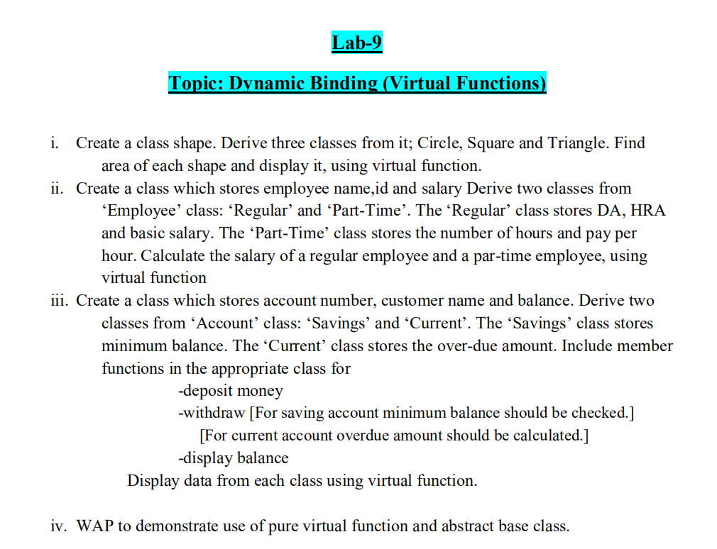

**1.**

#include<iostream>

#include<cstring>

using namespace std;

class Shape

{

public:

virtual void get_input()

{

cout<<"Shape's input fn called";

}

virtual void area()

{

cout<<"Shape's area";

}

};

class Circle:public Shape

{

int radius;

public:

void get_input()

{

cout<<"Enter radius of circle: ";

cin>>radius;

}

void area()

{

cout<<"\nArea of Circle is:"<<3.14*radius*radius<<endl;

}

};

class Triangle:public Shape

{

int b,h;

public:

void get_input()

{

cout<<"Enter base of triangle: ";

cin>>b;

cout<<"Enter height of triangle: ";

cin>>h;

}

void area()

{

cout<<"Area of triangle is: "<<0.5*h*b<<endl;

}

};

class square:public Shape

{

int l;

public:

void get_input()

{

cout<<"Enter length of square ";

cin>>l;

}

void area()

{

cout<<"Area of square is: "<<l*l<<endl;

}

};

int main()

{

Shape *p1,*p2,*p3;

Circle c;

Triangle t;

square r;

p1=&c;

p2=&t;

p3=&r;

p1->get_input();

p2->get_input();

p3->get_input();

p1->area();

p2->area();

p3->area();

}

**OUTPUT :**

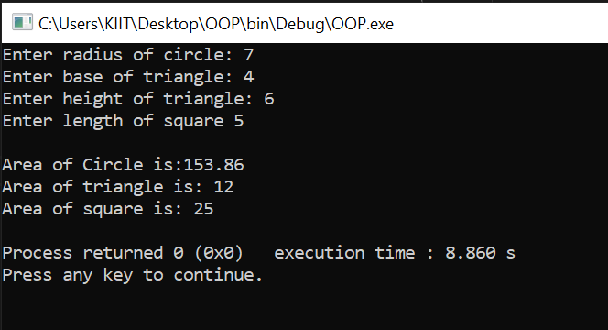

**2.**

#include<iostream>

using namespace std;

class employee{

public :

char name[25];

int id,salary,DA,HRA,hr,pph;

void info()

{

cout<<"Enter name : ";

cin>>name;

cout<<"Enter ID : ";

cin>>id;

}

void regular()

{

cout<<"Enter salary : ";

cin>>salary;

cout<<"Enter DA : ";

cin>>DA;

cout<<"Enter HRA : ";

cin>>HRA;

}

void part()

{

cout<<"Enter number of hours : ";

cin>>hr;

cout<<"Enter pay per hour : ";

cin>>pph;

}

virtual void sal() = 0;

};

class regular : public employee

{

public:

void sal()

{

cout<<"\nSalary of regular employee : "<<salary + DA + HRA<<endl;

}

};

class part : public employee

{

public:

void sal()

{

cout<<"\nSalary of Part-time employee : "<<pph*hr*30<<endl;

}

};

int main()

{

regular r;

employee *er = &r;

er->info();

er->regular();

er->sal();

part p;

employee *ep = &p;

ep->info();

ep->part();

ep->sal();

return 0;

}

**OUTPUT :**

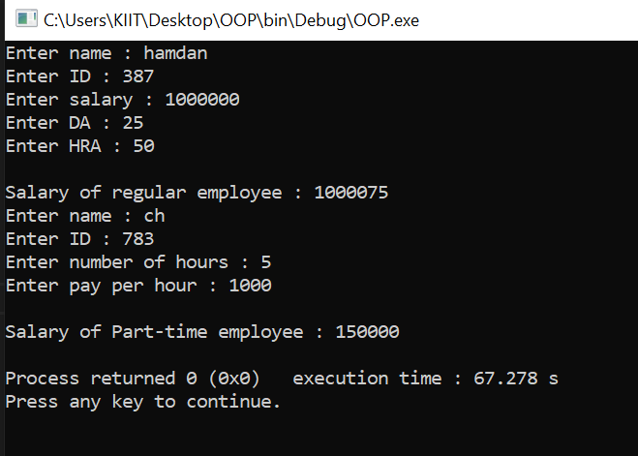

**3.**

#include<iostream>

using namespace std;

class account{

public:

int acn,balance,minbal,wd,dp,bal;

char name[25];

void info()

{

cout<<"Enter account number : " ;

cin>>acn;

cout<<"Enter name : ";

cin>>name;

cout<<"Enter balance : ";

cin>>balance;

cout<<"Enter amount to withdraw : ";

cin>>wd;

cout<<"Enter amount to deposit : ";

cin>>dp;

}

void savings()

{

minbal = 1000;

bal=balance-wd+dp;

cout<<"Minimum balance is : "<<minbal<<endl;

}

void current()

{

bal = balance-wd+dp;

cout<<"Current balance is : "<<bal<<endl;

}

virtual void data() = 0;

};

class savings : public account

{

public:

void data()

{

cout<<"Account number : "<<acn<<endl;

cout<<"Customer name : "<<name<<endl;

if(bal<minbal)

cout<<"You cannow withdraw below minimum balance, which is Rs. "<<minbal<<endl;

else

cout<<"Balance is : "<<bal<<endl;

}

};

class current : public account

{

public:

void data()

{

cout<<"Account number : "<<acn<<endl;

cout<<"Customer name : "<<name<<endl;

if(bal<0)

{

cout<<"Amount Overdued."<<endl;

}

else

{

cout<<"Balance is : "<<bal<<endl;

}

}

};

int main()

{

int ch;

savings s;

account *as = &s;

current c;

account *ac = &c;

while(1)

{

cout<<"1. Savings"<<endl;

cout<<"2. Current"<<endl;

cout<<"3. Exit"<<endl;

cout<<"Enter choice : ";

cin>>ch;

switch(ch)

{

case 1 : cout<<"Savings Account."<<endl;

as->info();

as->savings();

as->data();

break;

case 2 : cout<<"Current Account."<<endl;

ac->info();

ac->current();

ac->data();

break;

case 3 : return 0;

default: cout<<"Wrong Choice!!"<<endl;

}

}

}

**OUTPUT :**

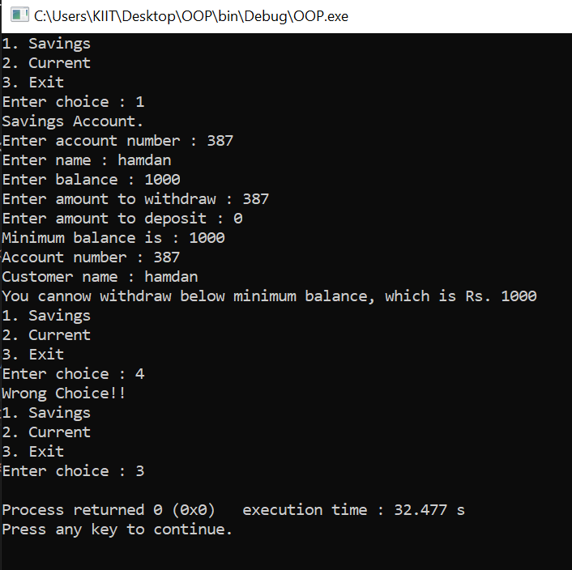

4.

#include <iostream>

using namespace std;

class Shape

{

protected:

float dimension;

public:

void Dimension()

{

cin >> dimension;

}

virtual float calculateArea() = 0;

};

class Square : public Shape

{

public:

float calculateArea()

{

return dimension * dimension;

}

};

class Circle : public Shape

{

public:

float calculateArea()

{

return 3.14 * dimension * dimension;

}

};

int main()

{

Square square;

Circle circle;

cout << "enter the th side of the square ";

square.Dimension();

cout << "\narea of square:"<<square.calculateArea()<< endl;

cout << "enter the radius of the circle" ;

circle.Dimension();

cout << "\narea of circle:"<<circle.calculateArea() << endl;

return 0;

}

**OUTPUT :**

